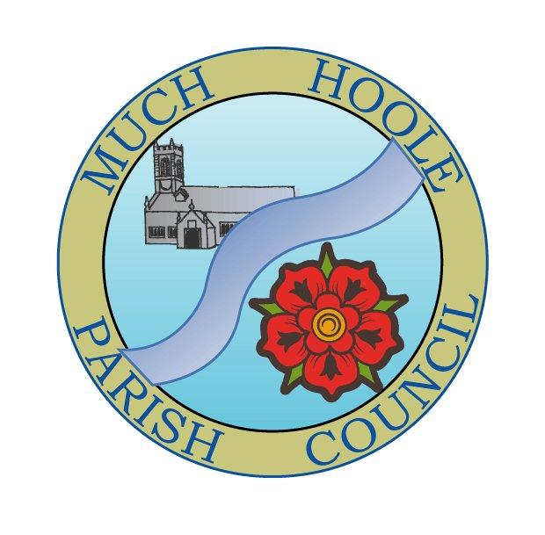
Minutes of the Parish Council meeting held on
Monday 13th June 2022 at 7.30pm. The meeting was held in the Venue, Liverpool Road, Much Hoole.

Present: Cllr Woodcock, Cllr Hewitt, Cllr Lea, Cllr Houghton R.Weaver (Clerk)

1. | Apologies for Absence  To receive apologies for absence:  Cllr Brown, Cllr Hayes, Cllr Cocker, Cllr Taylor
2. | Declaration of Interests and Dispensations  - Cllr Houghton re village hall update (non-pecuniary)
3. | Minutes of last meeting  Minutes of the 9th May 2022 were agreed and signed
4. | Public Time  As there were no members of the pubic present and the meeting was not adjourned
5. | Planning  There were no planning issues relevant to Much Hoole
6. | Cycle Track  The intention is still to install a picnic bench at the cycle track when the concrete base has been laid.
7. | Finance and Audit  To authorise payment of the following:  - It was resolved to pay the Clerk in sum of £240 net pay (for May)  - It was resolved to pay the Clerk mileage expenses in the sum of £9.45  - It was resolved to pay HMRC in sum of £60 PAYE (for May)  - It was resolved to pay the internal auditor fee of £100 to Mr Ian Edwards and to note that he is retiring as internal auditor. The Council recorded its thanks for his professional services in rednt years.  - The Council noted and approved the internal audit report  - The Council noted and accepted the AGAR Statement of Governance which was signed by the Chairman  - The Council noted and accepted the AGAR statement of accounts which were signed by the Chairman  - The Council set the period of public rights to inspect unaudited accounts as Monday 20th June to Friday 29th July and posters and notices will be posted accordingly
8. | Community led projects  Community Garden  Cllr Hewitt proposed that a sum of money of up to £500 be allocated to a community garden, where anyone can use a provided plot of land to grow food and fruit. The benefits of this would be community involvement, education, learning resources and awareness of food and healthy eating for children.  It was agreed that £5000 be set aside in the budget and that a suitable plot of land should be explored, perhaps on the cycle track with the permission of the landowner.  The Trafalgar Gardens may be another potential area and there may be scope for that land to be used under the terms of an existing agreement with SRBC and the parish Council which has previously developed the area as a garden (although this would need to be checked)  It was agreed that the possibility of a gate into the Trafalgar garden would be beneficial as the area is currently fenced off with no access to the public and a gate that is locked shut  Parking  The village has an ongoing problem with traffic flow caused primarily by the development of housing and the residential care home. Development in this area around Liverpool Old Road near to the junction with Smithy Lane has simultaneously increased the need for parking space whilst reducing the availability of it. The net result is considerable congestion from cars parked on the road making two-way traffic difficult to maintain, and in the case of larger vehicles such as buses and commercial vehicles, impossible.  Short term measures such as parking notices and liaison with the care home to minimize congestion have been tried but the problems are considerable particularly when the playing fields and pub are in use.  The Council felt this was an increasing problem highlighted by people in the village and agreed that it should be placed on the next agenda to discuss some longer-term solutions if there are any.
9. | Footpath repairs  Councillor Cocker remains very active in walking and inspecting the footpaths. FP 22 has been repaired and LCC has been notified that it van remove it from their list of pending jobs. Further repair work is being identified which can be completed by the Parish Council rather than LCC under the delegated scheme.  It was agreed that the existence of the footpaths and their locations and routes should be better advertised.
10. | Village hall Update  Councillors were asked to note the verbal report fro Cllr Houghton and the written report from Cllr Taylor on behalf of the trustees. The Work on the car park has been completed and looks much more appealing than the old gravel surface. There has been some planting around the outside of the hall and the car park. The hall played host to the recent Jubilee lunch which was a great success. The survey which supported the idea of a MUGA is being considered further.
11. | LCC and Parish Council working Charter  Representatives of Parish Councils and LCC have produced a charter documenting how they can work effectively together. The Council noted the charter
12. | Grants  The Council was asked to note that grants previously approved are still held in the Council bank accounts and have not yet been transferred to the recipients, until such times as the receipts or invoices are received.
13. | Reports from other meetings  There were no meetings to report. The next LALC executive meeting will be held on 18th June 2022
14. | Items for the Next Agenda  To receive an update on planning permission for signage around the village  To consider proposals for alleviating car parking problems on Liverpool Old Road.
15. | Date of Next Meeting  The Parish Council agreed the date of the next meeting as 7.30pm 11th July 2022 at the Venue

